Laboratory work 8
VIEW.
- Create a view to show details of all flights that are departing on a specific date.
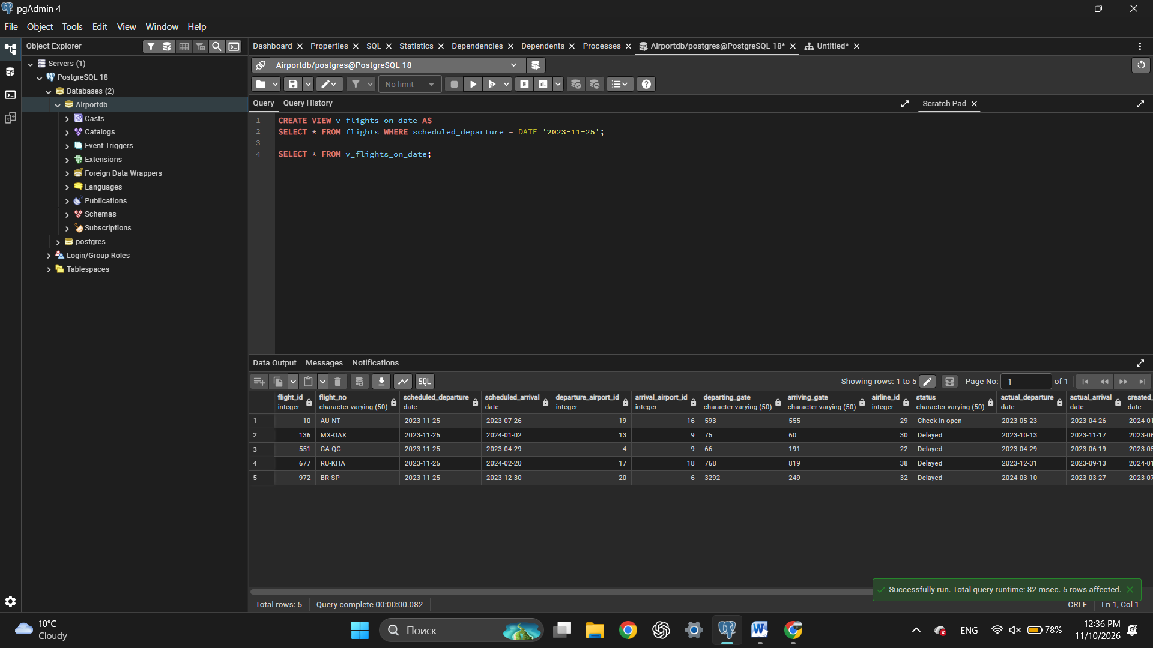
- Create a view that shows bookings for flights scheduled to depart within the next week.
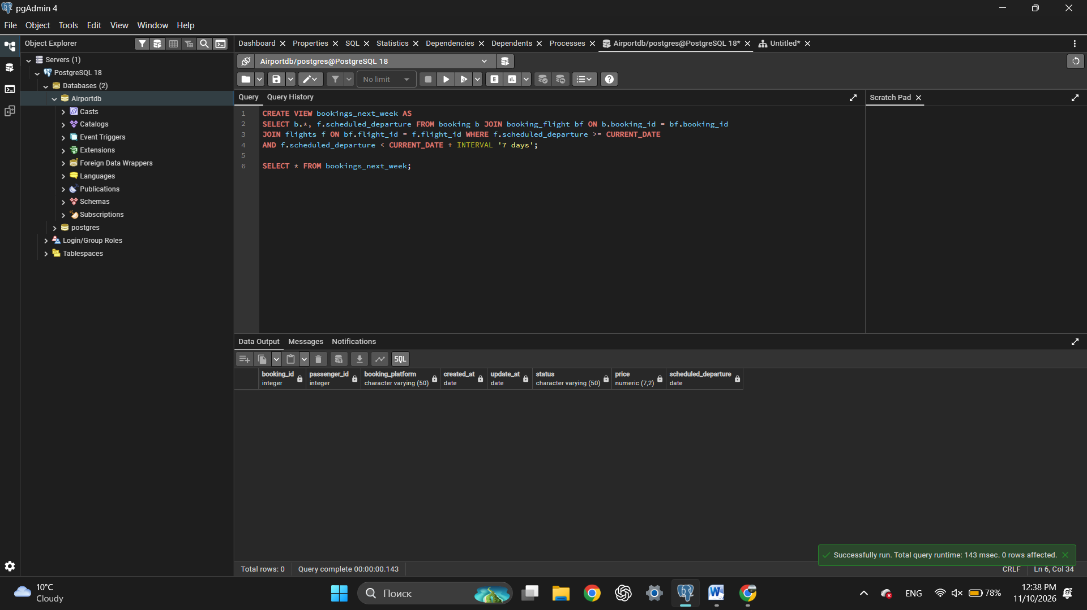
- Create a view to show the top 5 most popular flight routes based on the number of bookings.
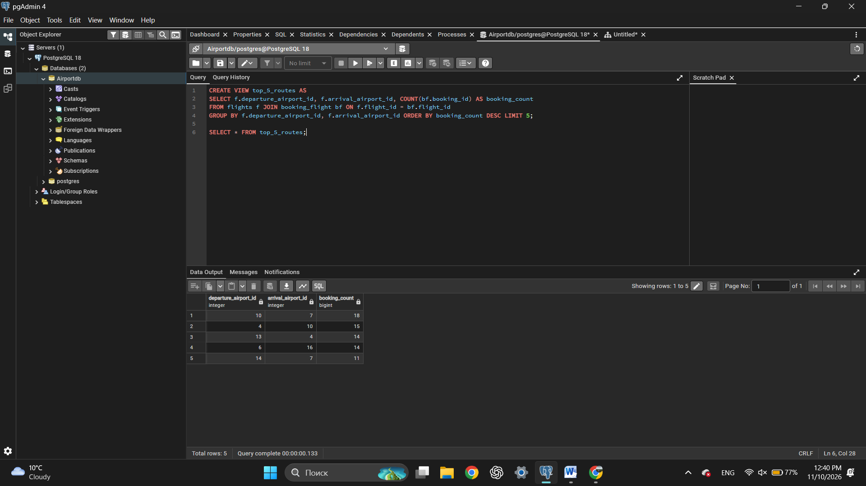
- Create a view that lists all flights for a specific airline.
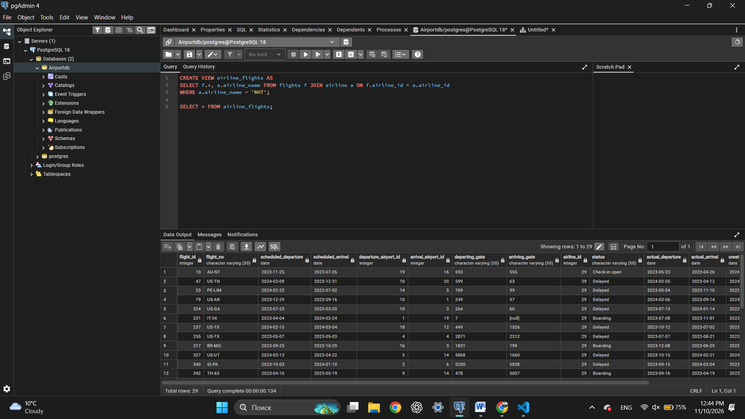
- Modify the view created in task 4 to show only flights departing within the next 7 days for a specific airline.
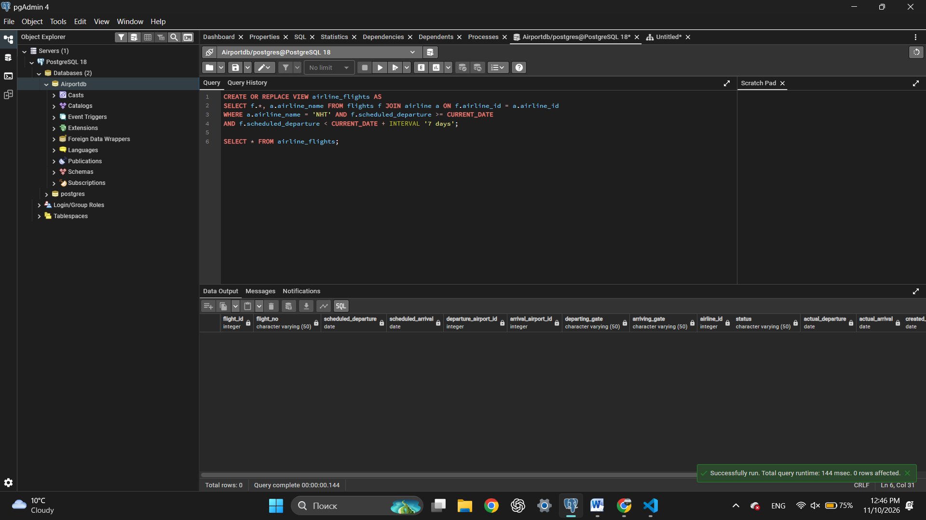
- Create a view to show flights that are delayed by more than 24 hours.
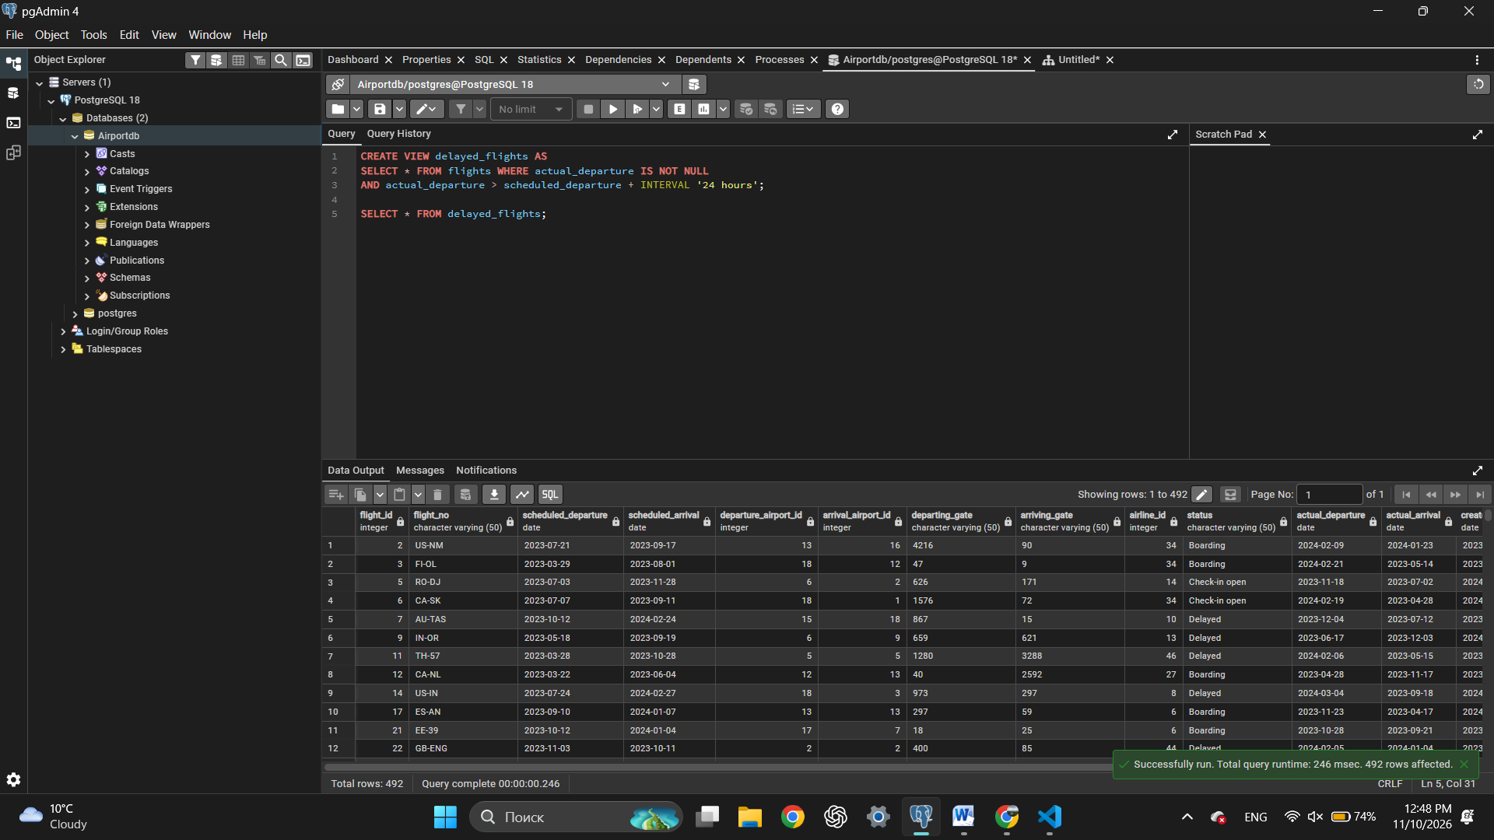
- Create a view in which you can display the full name and country of origin of passengers who made bookings on Leffler-Thompson platform. Then show the list of those passengers.
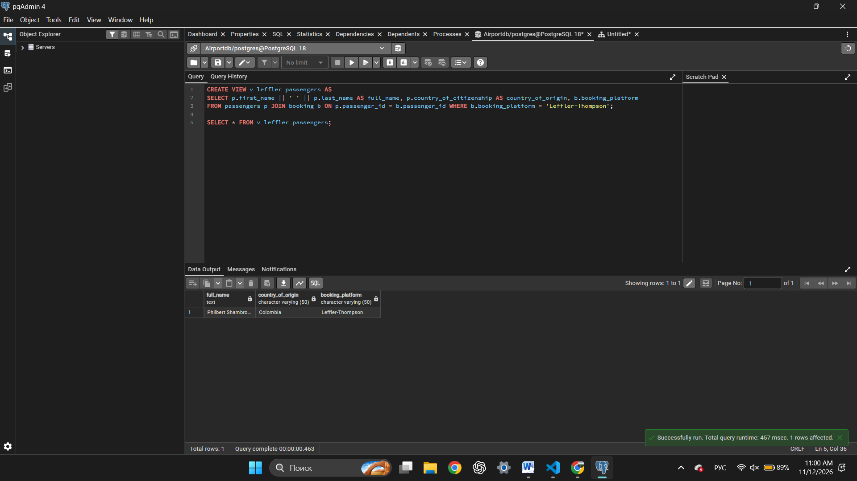
- Create a view that shows top 10 most visited countries.
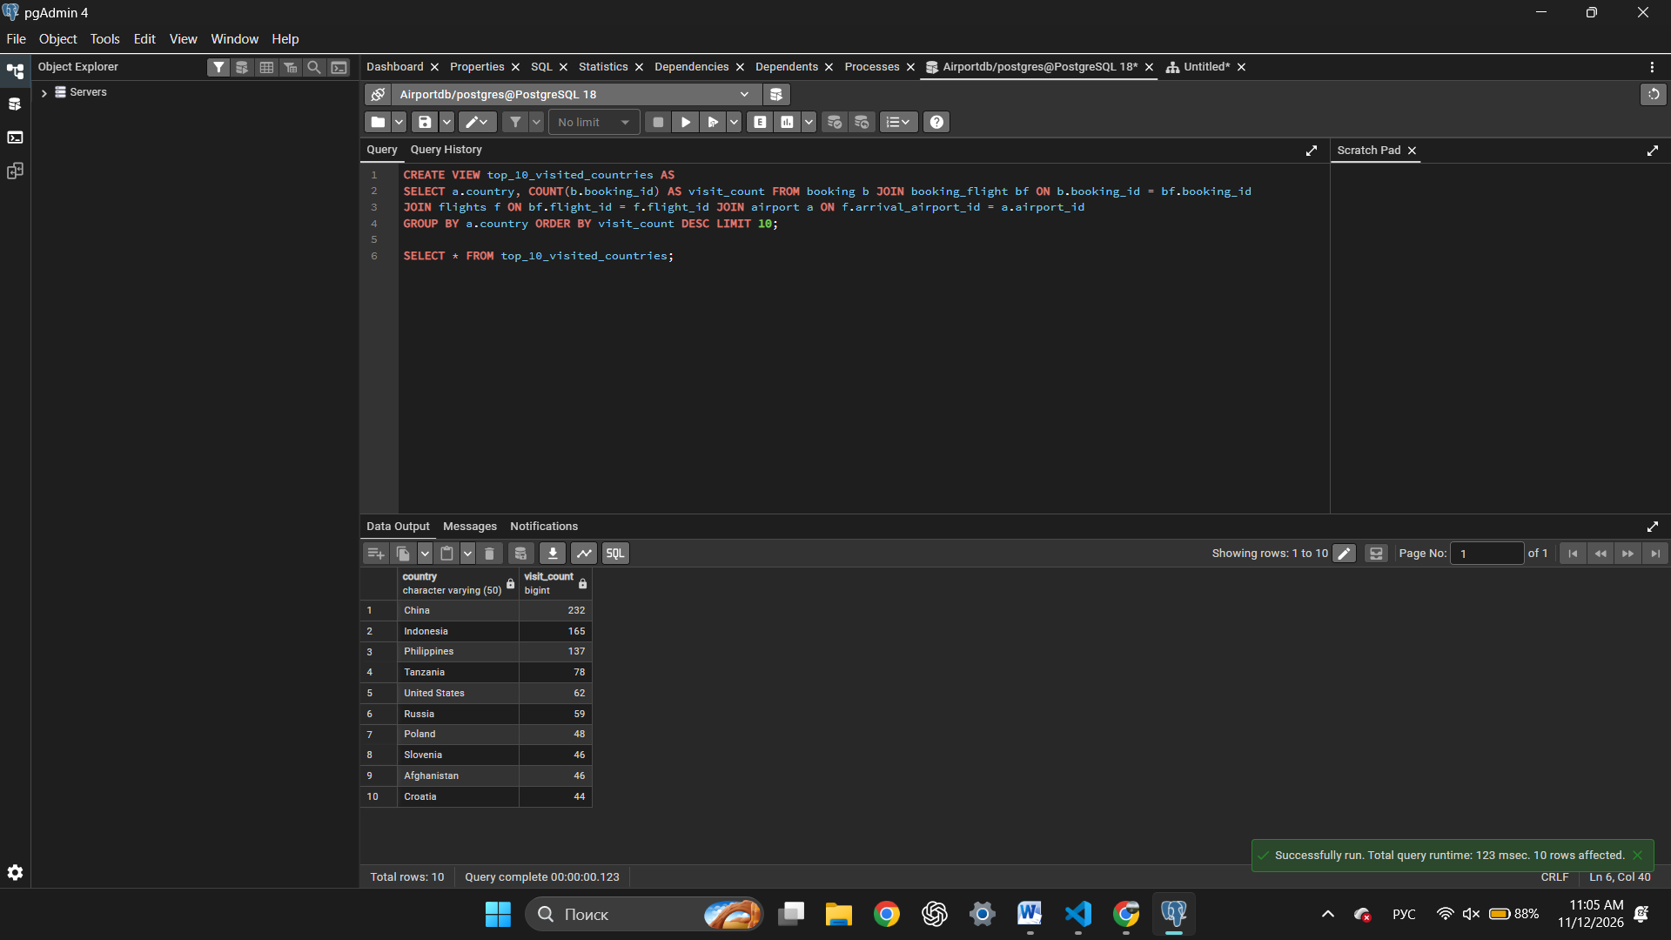
- Update any of the created views by adding new information in the view table. Show results.
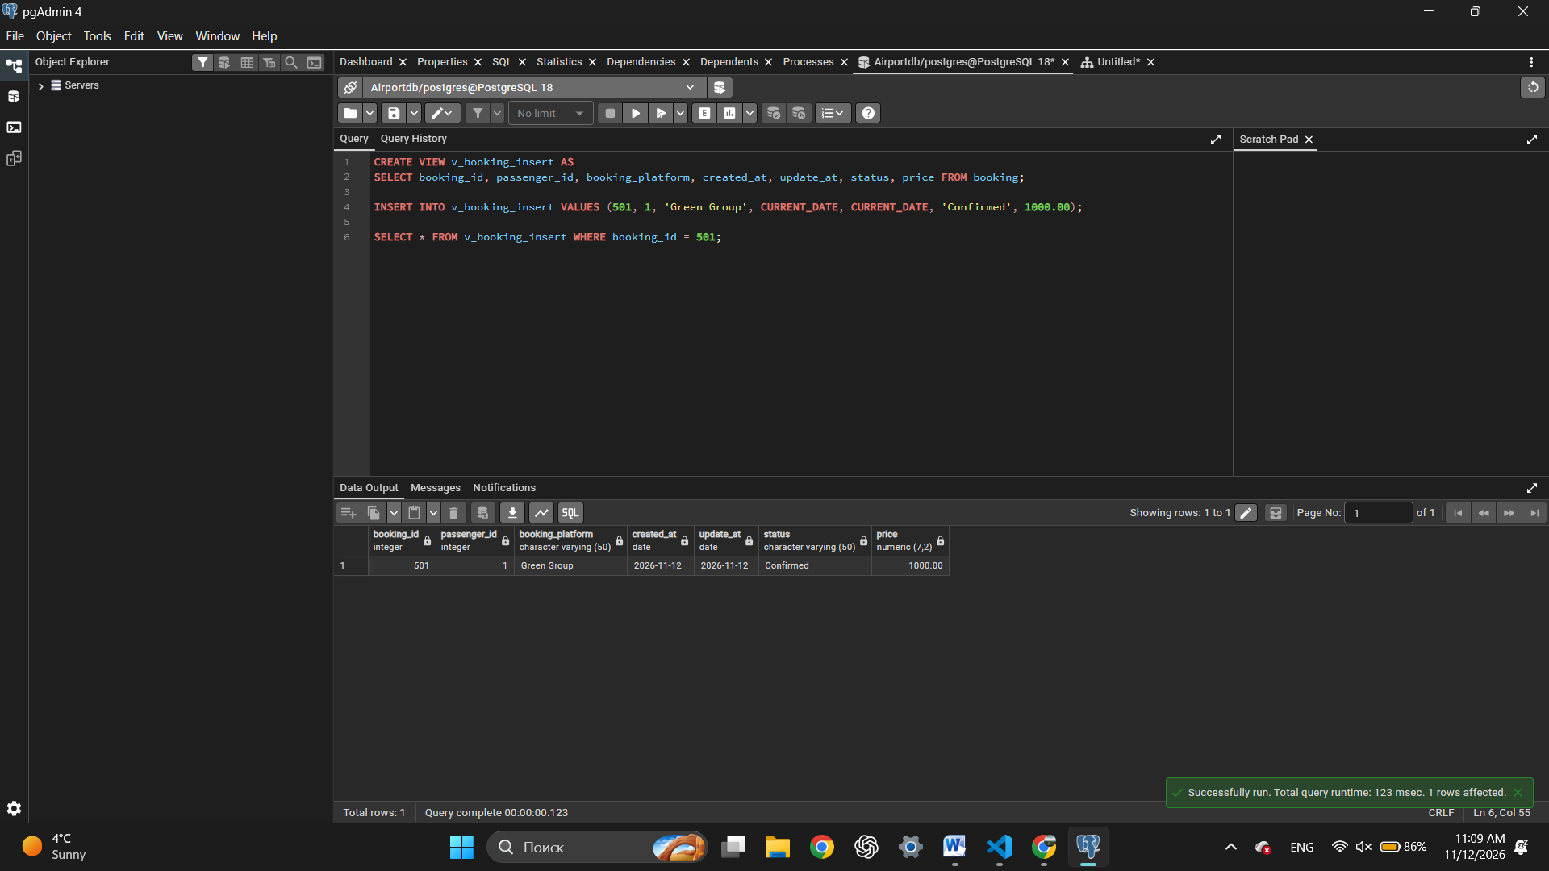
- Drop all existing views.
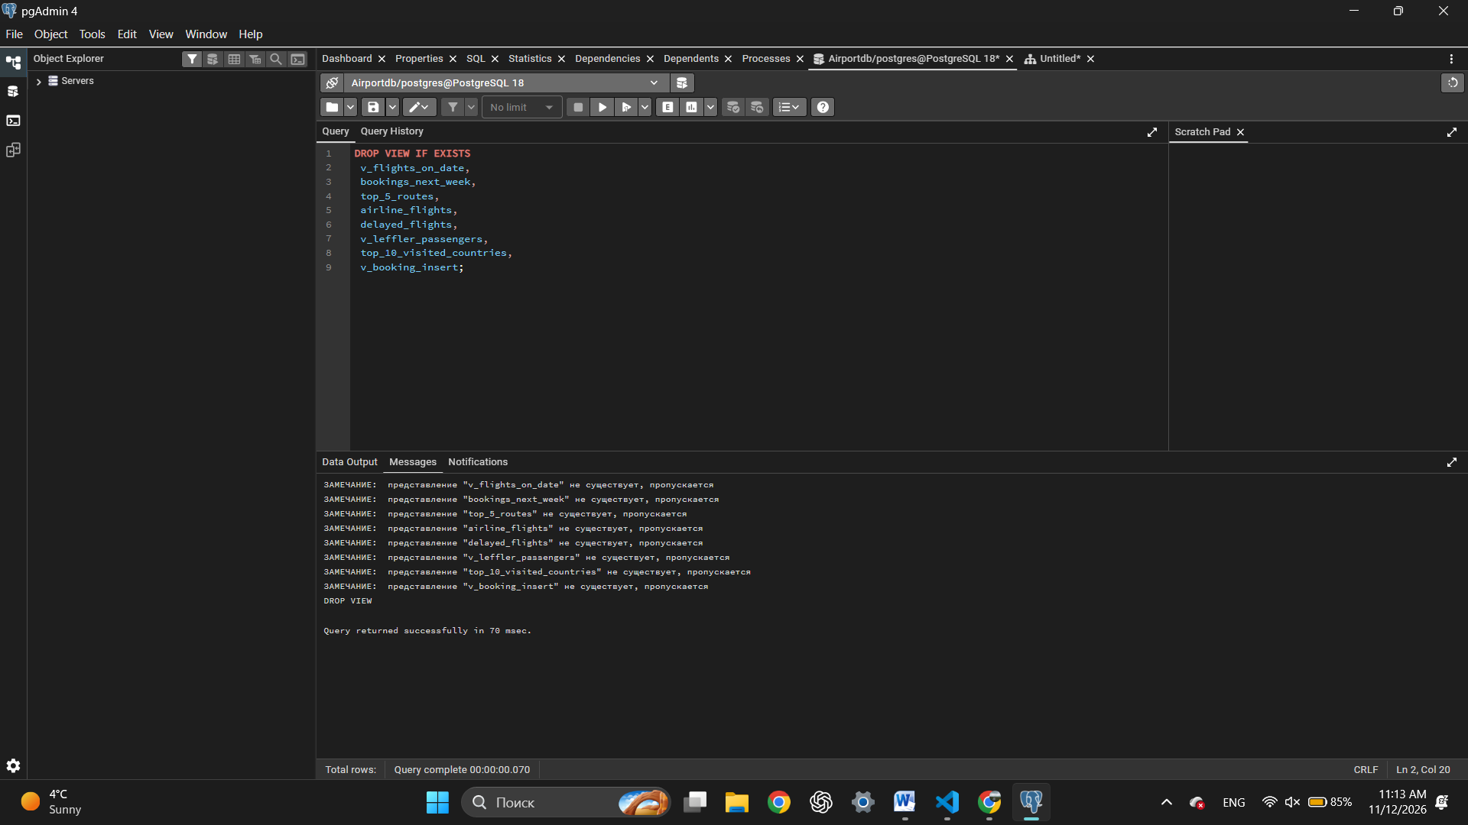
ROLES.
- Create the group roles flight_manager and flight_analyst, then show the list of roles.
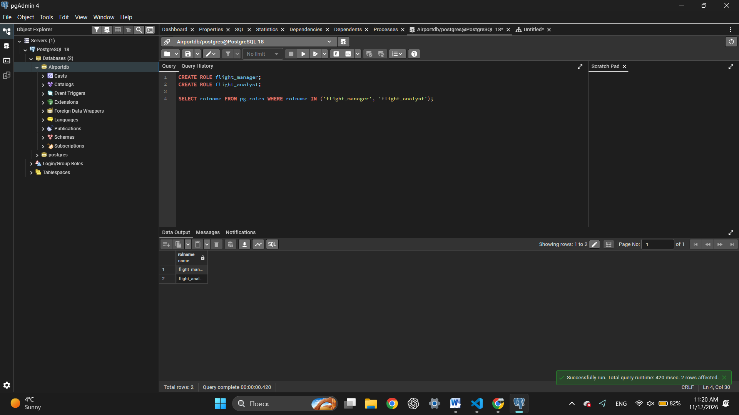
- Create the users first_user and second_user and add them to the group roles.
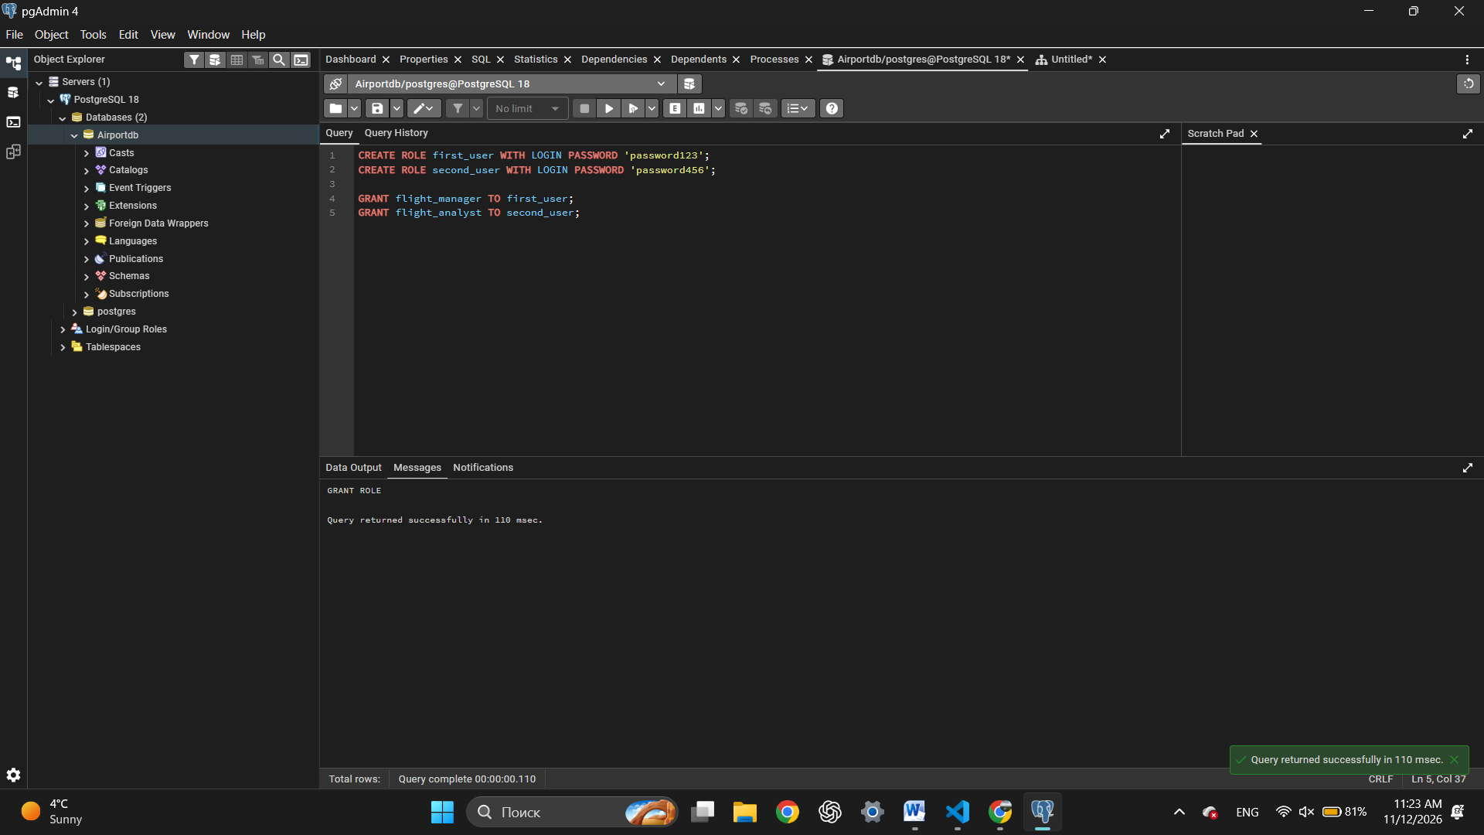
- Grant flight_analyst SELECT on the flights, airlines and bookings tables.
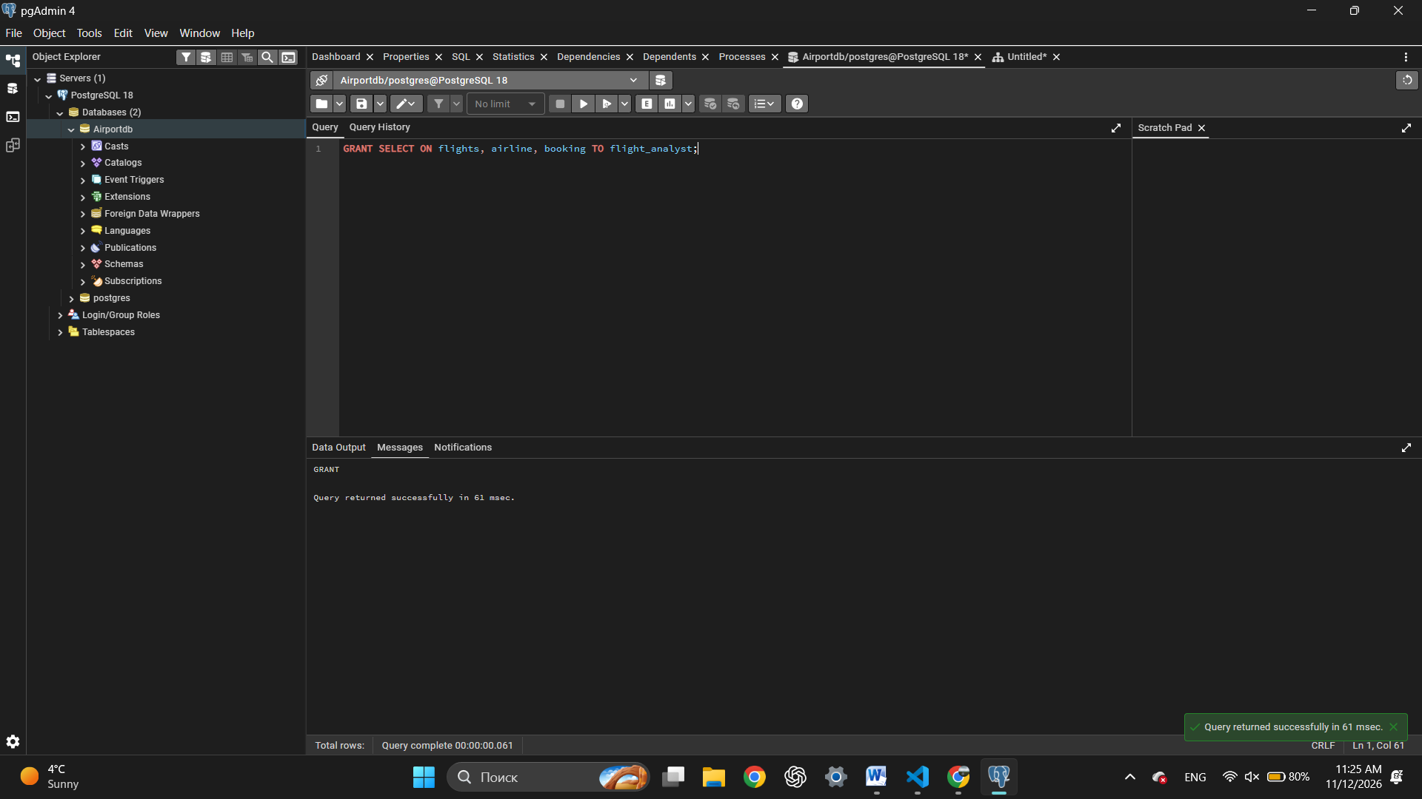
- Grant flight_manager SELECT, INSERT and UPDATE on bookings, and SELECT on the other tables.
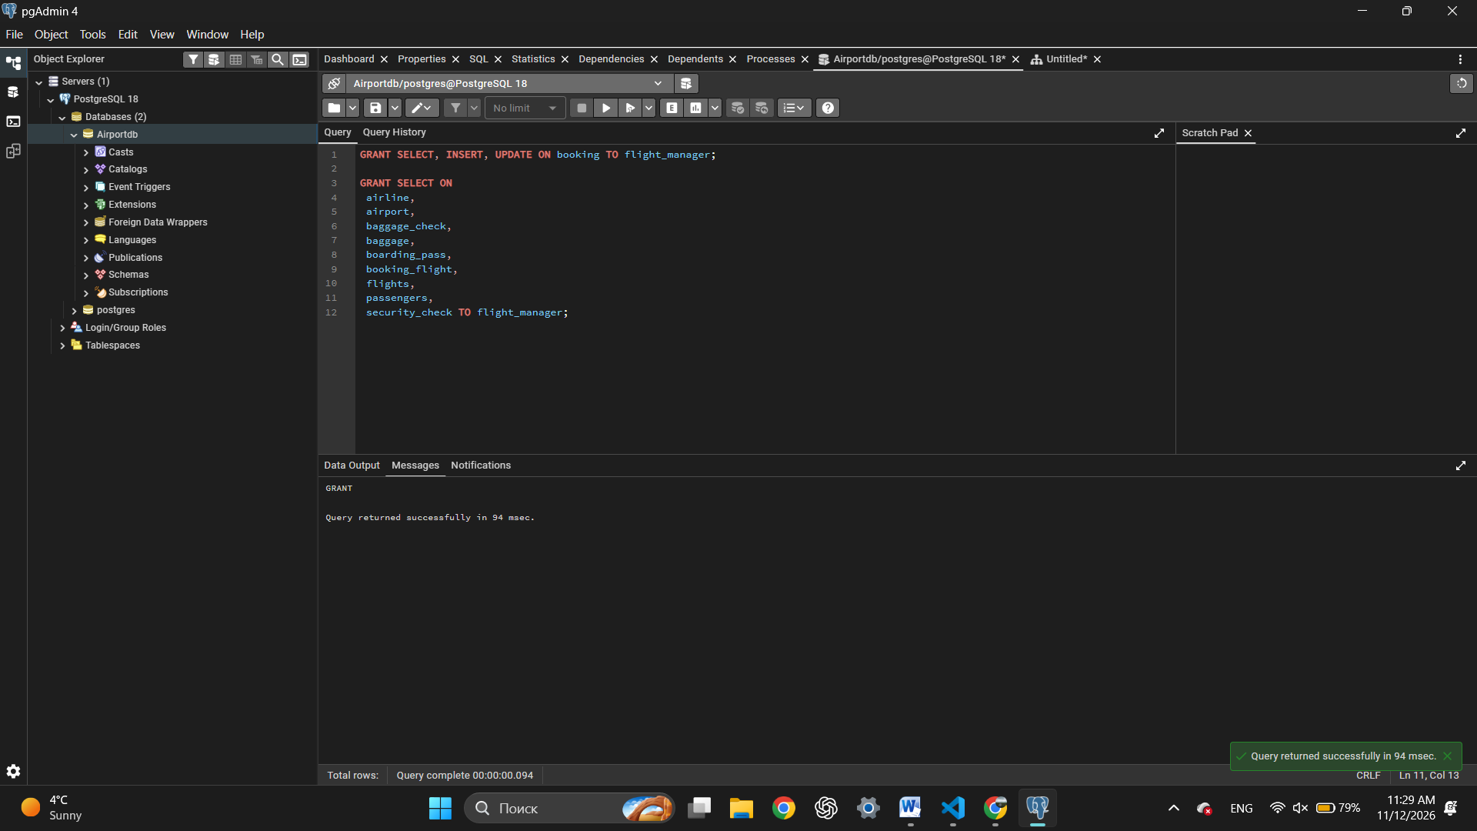
- Connect as second_user, read flights and try to delete from bookings.
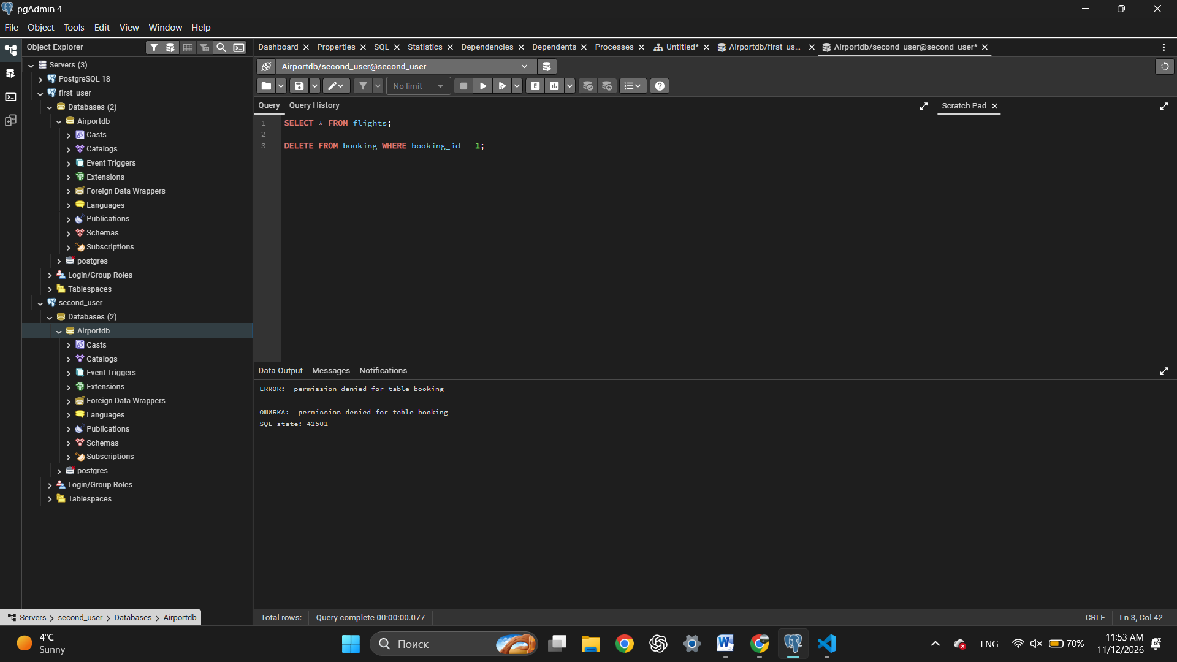
- Connect as first_user, insert and update a booking, and try to delete one.
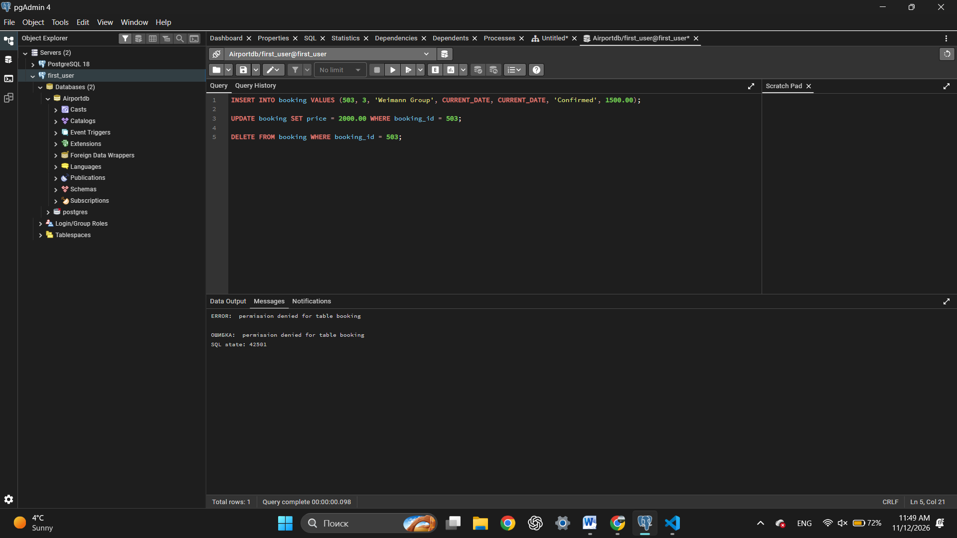
- Grant column-level SELECT on only the full name and country columns of passengers.
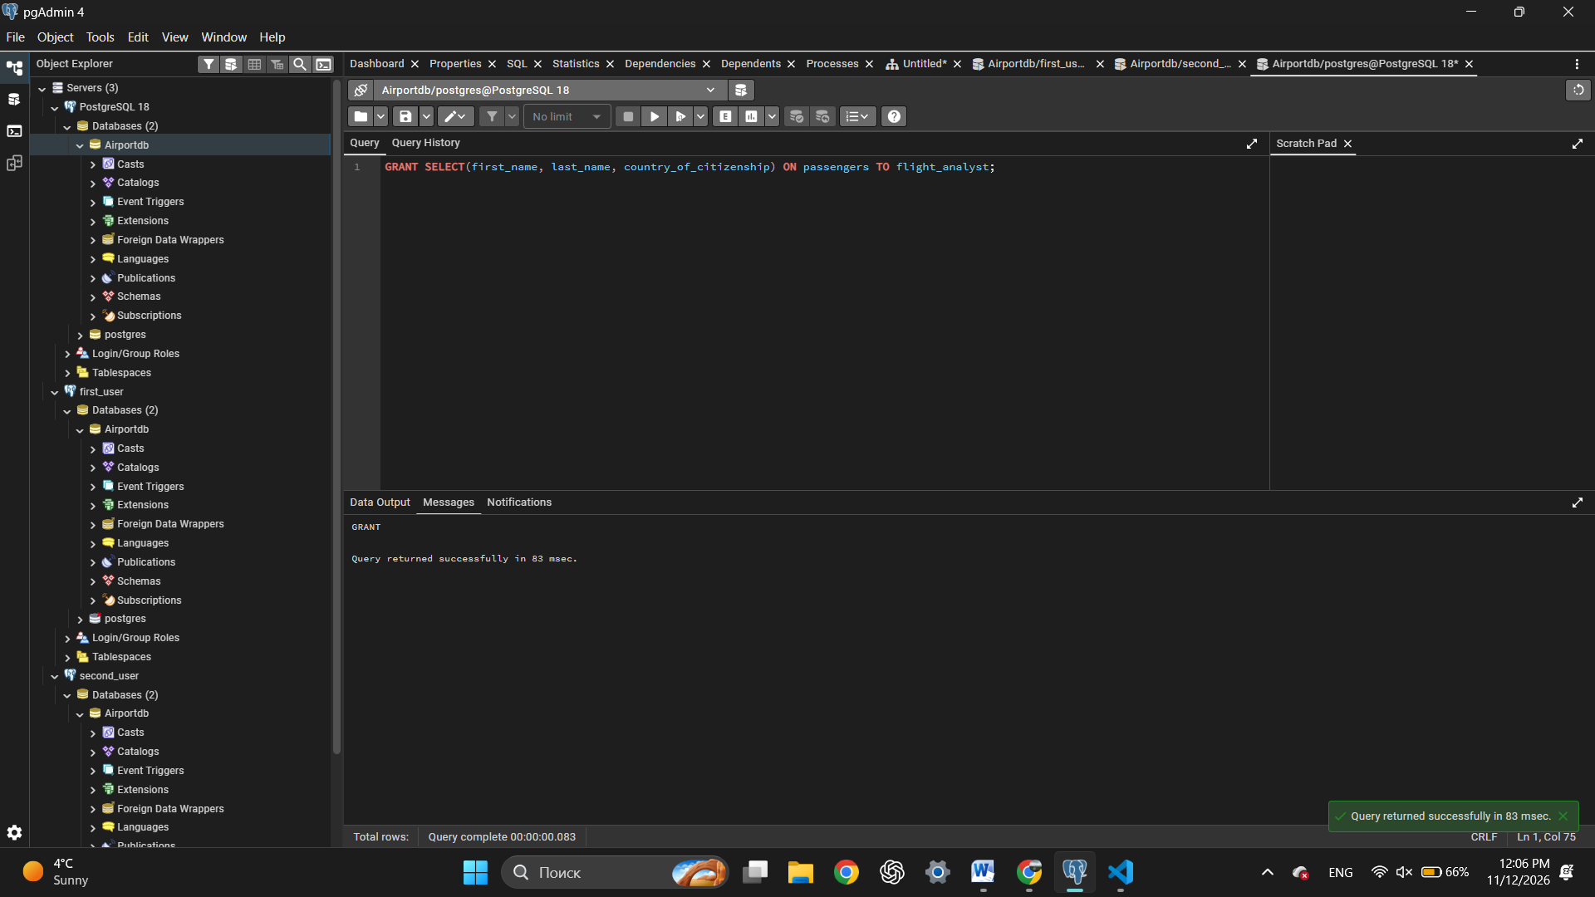
- Revoke SELECT on bookings from flight_analyst and show that access is denied.
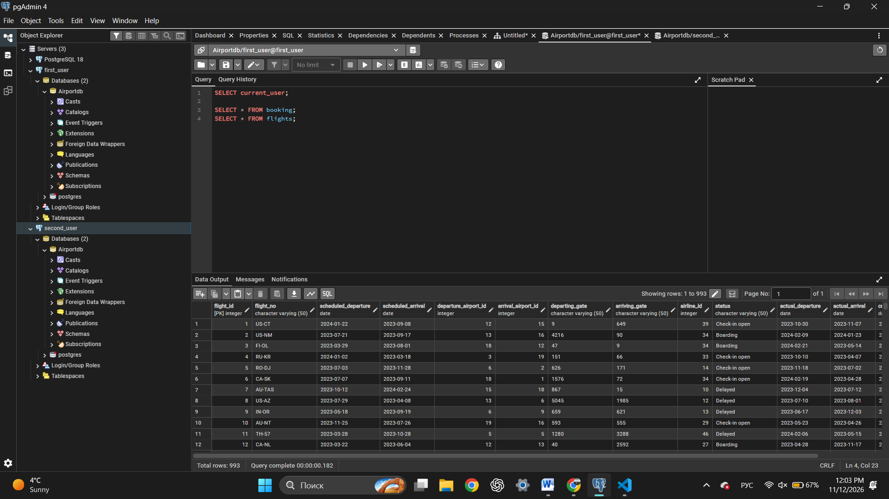
- Alter the roles: change a password, set a connection limit and rename a role.
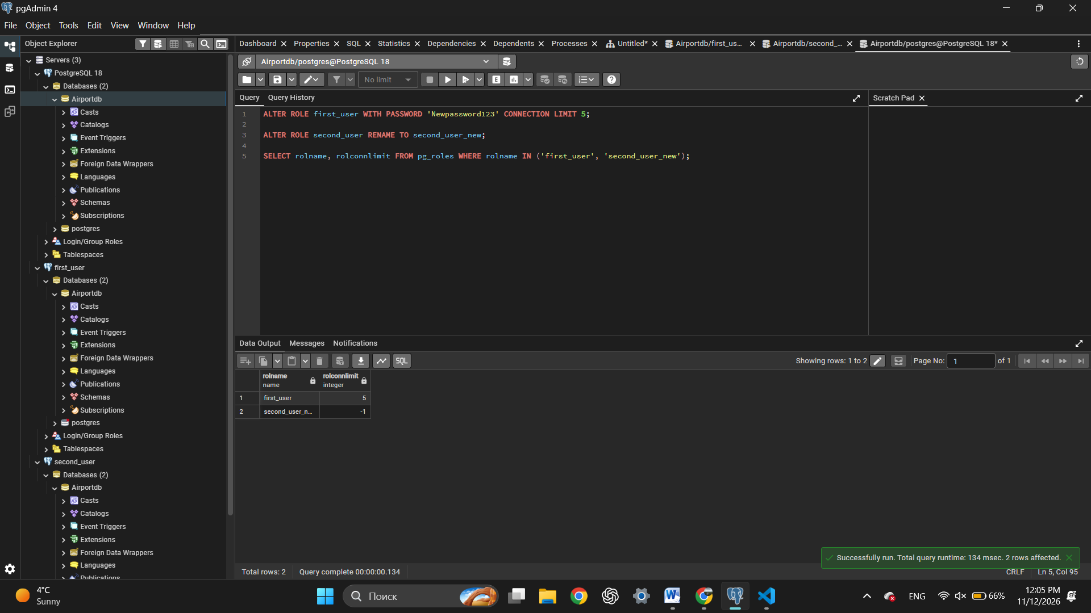
- Drop all created roles.


